Maharshi Patanjali Vidya Mandir Prayagraj
HOLIDAYS HOME WORK
Of
Class XII- Humanities

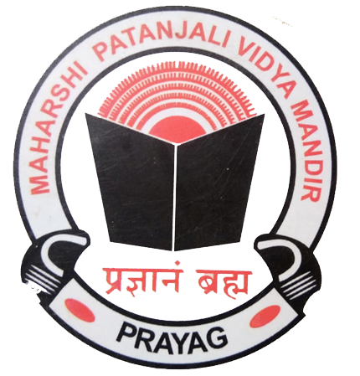

"Education's purpose is to replace an empty mind with an open one."
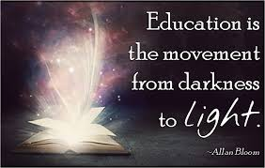
"You learn something every day if you pay attention."
English | - Q. Q.1. The Smiths are an old couple. They own a puppy which they wish to sell to a genuine buyer who would look after it properly. Draft a suitable advertisement for the classified column of a local newspaper giving details in about 50 words, about its age and other relevant features.  - Q.2. Your grandfather left the house a week back and is missing since then. Draft an advertisement for the newspaper.  - Q.3 Kritika Thakur has lost her original School certificates in the Rajdhani Express while coming back from Mumbai. She decides to give an advertisement in The 'Lost and Found,' column of the newspaper. Draft an advertisement for her.  - Q4. Mr S.S Sandhu has found a passport in the Indira Gandhi International Airport, New Delhi. Draft a suitable advertisement for the classified columns of the local daily giving all the relevant details.  - Q5. Prem/ Prema Anand wishes to sell his/ her car because of an official promotion that will make him/ her stay in Dubai for a period of two years. Draft a suitable advertisement to attract good buyers.  - Q6. Draft a notice giving all details to be sent to the students of class 12 to team up (groups of eight each) online and produce videos to be released on June 12 on the occasion of World Day against Child Labour.  - Q7. You are Manik/ Mani Chaudhury, the founder & secretary of a now renowned NGO- Holding Hands. Ask your creative team to design a powerful poster on spreading awareness regarding Social Distancing during this time of COVID-19. The poster is meant to be put up in the slums and labour colonies of your city.  - Q 8. Restaurants are operating after almost two months of lockdown. Design an attractive advertisement for your own setup and how you are providing services to reach out to your customers in the city
Psychology | - Revise the chapters:  - Variations in psychological attributes  - Self and Personality  - Meeting life challenges  - Define all the key terms given at the end of the chapters  - Answer all the questions given at the end of all the three chapters neatly in your notebook
History | Thoroughly read and revise the chapters:  -Through the eyes of travelers  -Bhakti and the Sufi Traditions  -Colonialism in the countryside  -Rebels and Raj  * Make a project on any one of the following topics for your final exams. The project should be made in a file. It should be informative, present table, and covered properly.  The topics are:  1.The mysteries behind the mound of dead–Mohenjo-Daro  2. An In-depth study to understand Spiritual Archaeology in the Sub-Continent  3. Buddha’s Path to Enlightenment  4. Insight and Reflection of Bernier’s notions of The Mughal Empire  5. An exploratory study to know the women who created history  6. “Mahatma Gandhi” – A legendary soul  7. To reconstruct the History of Vijayanagar through the Archaeology of Hampi  8. The emerald city of Colonial Era –BOMBAY  9.Vision of unity behind the first war of Independence  10.Divine Apostle of Guru Nanak Dev  11.Help, Humanity and Sacrifices during Partition  12.Glimpses inside Mughals Imperials Household  13.The process behind the framing of the Indian Constitution 14.The ‘Brahm Nirupam’ of Kabir – A journey to Ultimate Reality  * Do the map work mentioned in your chapters.
Economics | Indian Economic Development –  - State of Indian Economy on the Eve of Independence  - Common Goals of Five year Plans  - Growth and Development of agriculture, industry and foreign trade  Make notes and complete the exercises given for the following chapters covered in class.  Read the chapter Economic reforms since 1991  Macro – Economics –  - National Income and related aggregates  - Money & Banking  Learn and complete the exercises for the above mentioned chapters  Practice doing the numerical of National Income along with diagram of circular flow.  Project – Work –  From the topics given in the suggestive list of projects select any one and make a blueprint.  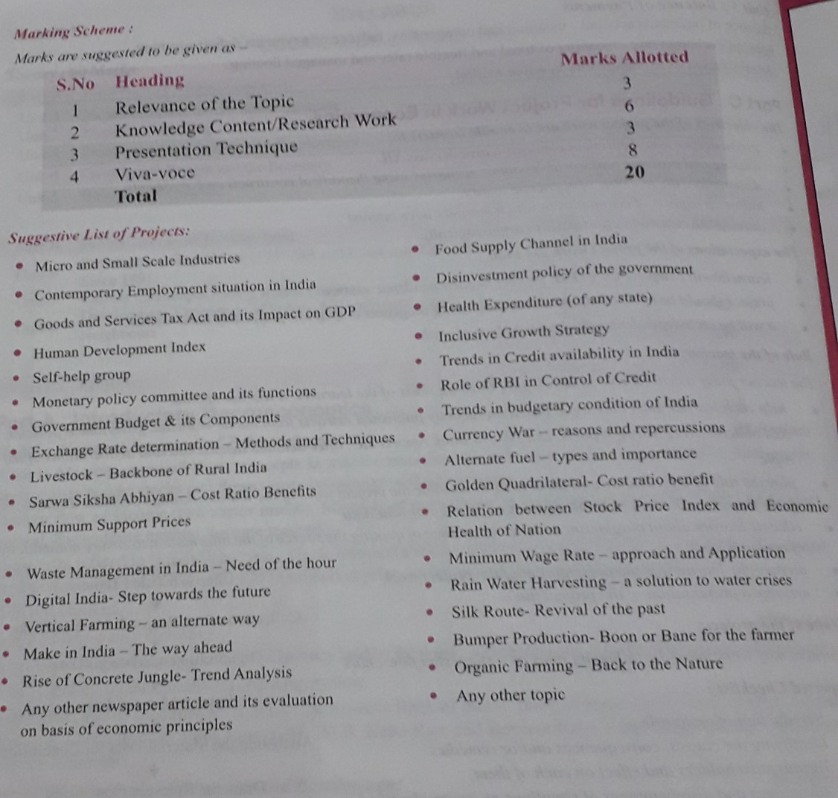
Informatics Practices | - Write short note on the following-  1) Computer Network 11) Network Topologies 21) Digital footprint  2) LAN 12) Introduction to Internet 22) Data protection  3) MAN 13) URL 23) Intellectual property rights (IPR)  4) WAN 14) WWW 24) Plagiarism  5) Modem 15) email 25) Free and Open Source S/W (FOSS)  6) Hub 16) Chat 26) Cybercrime and Cyber laws  7) Switch 17) VoIP 27) Hacking  8) Repeater 18) Website and webpage 28) Phishing  9) Router 19) Static vs dynamic web page 29) Overview of Indian IT Act.  10) Gateway 20) Web server and Hosting 30) E-waste: hazards and management.  - Write the uses of following function in MySQL:  1) POWER () 8) LENGTH () 15 NOW () 22) MAX ()  2) ROUND () 9) LEFT () 16) DATE () 23) MIN ()  3) MOD () 10 RIGHT () 17) MONTH () 24) AVG ()  4) UCASE ()/UPPER () 11) INSTR () 18) MONTHNAME () 25) SUM ()  5) LCASE ()/LOWER () 12) LTRIM () 19) YEAR ()  6) /SUBSTRING ()/SUBSTR () 13) RTRIM () 20)DAY ()  7) MID () 14) TRIM () 21) DAYNAME ()
Physical Education | 1. Revision of chapters and make a short notes.  Unit 1 : Planning in sports .  Unit 2 : Sports and Nutrition.  Unit 3: Yoga and Lifestyle ---- Practice of Pranayam , Asanas and Suryanamaskar in morning, exercise in evening and meditation(Before sleeping) as per teacher guideline , take help of PDF of Yoga book and YouTube link .  4: Solve all the questions given at the end of each chapters.  5: Make a practical file.  6: Tratak exercise (Be careful )  Note : If any Problem then discuss with me Morning time 8am to 10am. (9005820854 ) or write your problem in whatsapp group (Physical Education).
Hindi | - बताए गए विषयों में से किसी एक विषय पर परियोजना कार्य पूरा कीजिए  - 2. बच्चा पढ़ेगा तो देश बढ़ेगा इस विषय पर एक फीचर लिखिए  - कक्षा में पढ़ाई गई कविताओं का काव्य सौंदर्य लिखिए  - जल है तो कल है इस विषय पर एक आलेख लिखिए  - पढ़ाए गए सभी पाठों को पुनः पढ़िए एवं प्रश्न उत्तर याद कीजिए
Legal Studies | - Go through the CBSE text book.  - Do all the objective type questions sent to you on the WhatsApp in your note book  - Visit the sites of NHRC, NCW, NCM, NCSt, NCSc and read the cases decided by the commission  - Complete your project
GS/V.Edu. | Make the projects discussed in the class  Read the newspaper daily
SEWA

“The aim of education should be to teach us rather how to think, than what to think — rather to improve our minds, so as to enable us to think for ourselves, than to load the memory with thoughts of other men.”

What we learn with pleasure we never forget.”

“Education is the passport to the future, for tomorrow belongs to those who prepare for it today.”
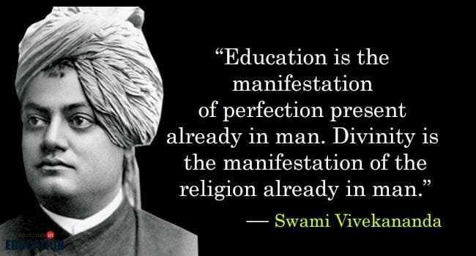

ENJOY YOUR HOLIDAYS

